34.91: 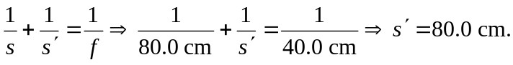
So the object distance for the second lens is 52.0 cm – (8.00 cm) = 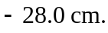
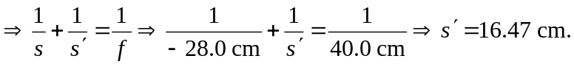
So the object distance for the third lens in 52.0 cm – (16.47 cm) = 35.53 cm.
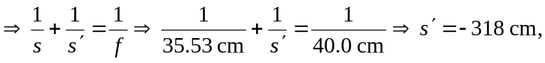 so the final image is virtual and 318 cm to the left of the third mirror, or equivalently 214 cm to the left of the first mirror.

